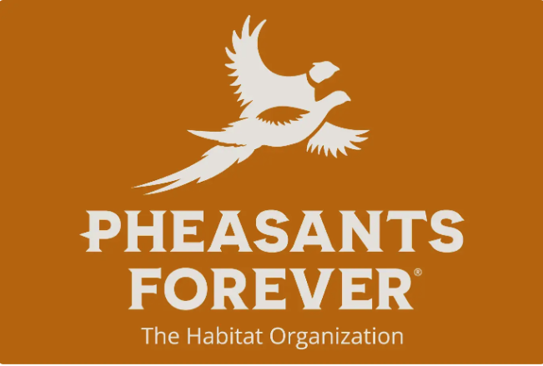 Fond du Lac County Pheasants Forever Chapter 0582

Rental Contract for 8’ Aitchison No-Till Drill

Landowner/Renter Name_________________________________________________________

Landowner/Renter Adress________________________________________________________

Location where drill will be used___________________________________________________
The landowner/renter agrees as follows:
- To provide suitable equipment with operator to pull the drill.
- To assume all liability in case of accident while the equipment is in use or being transported (if being transported by the landowner/renter).
- To pay FDL Pheasants Forever Chapter 0582 for the cost of repairs to the machine in the event that it is damaged through the fault or neglect of the landowner/renter.
- Pickup/Delivery date and time: _______________________________________
Return Delivery/Drop off date and time: ________________________________
Number of acres_____________________
- To pay FDL County Pheasants Forever Chapter 0582 for the use of the drill at the following rate:
  - ____________________
  - Full payment should accompany this contract.
  - Make all checks payable to FDL COUNTY PHEASANTS FOREVER CHAPTER 0582.

_____________________________________________ Date_____________________
Signed by (Landowner/Renter signature)

A $50 refundable deposit must accompany this contract. (Refunded when drill is returned cleaned.)

